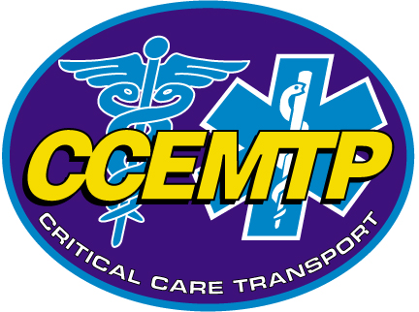
CCEMTP^{sm}/PNCCT^{sm} RETEST PROCEDURES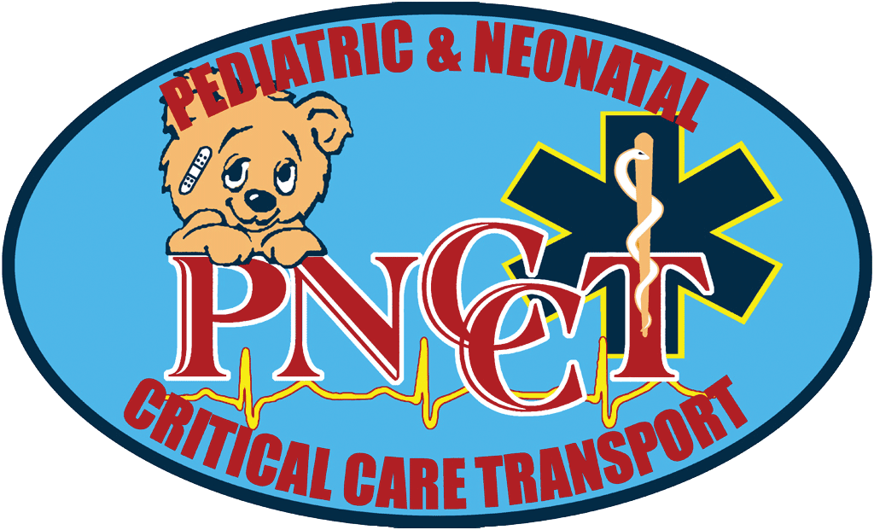
(effective April 15, 2013)

- Students may retest two (2) times within 12 months of the initial exam date. Subsequently, will be required to repeat the entire course.

- There is a $75 fee to retest each time. The check should be made payable to “UMBC” and mailed to:

DEPT. OF EHS/PACE
UMBC – AC IV RM. 308
1000 HILLTOP CIRCLE
BALTIMORE MD 21250

- Students are encouraged to reschedule a retest within a month of the initial exam.

- A list of upcoming CCEMTP^{sm} test dates and locations throughout the nation may be found on our website: http://ehs.umbc.edu/ce/CCEMT-P/index.html

- A list of upcoming PNCCT^{sm} test dates and locations throughout the nation may be found on our website: http://ehs.umbc.edu/ce/PNCCT/index.html

- IT IS THE STUDENT’S RESPONSIBILITY to contact the course coordinator at the location where you wish to retest. This information is listed on our CCEMTP^{sm} website.
  - Make sure the course coordinator has room to accommodate you during their final exam and if there is a re-test fee for the site.
  - Once the course coordinator approves you to sit for the exam at their site, you must contact Sandy Hubbard AT LEAST TEN (10) DAYS PRIOR TO THE REQUESTED EXAM DATE to arrange a retest packet be sent to the site. Sandy may be contacted at 410-455-6241, 410-455-6713 (fax) or email shubbard@umbc.edu.
  - Students are encouraged to re-contact the site coordinator the day prior to the exam to confirm the exact time and location of the exam.

- The student may also contact Sandy to arrange a retest at UMBC during normal working hours Monday-Friday, 9:00 am – 5:00 pm (excluding UMBC holidays).

- The student may also request to retake the final exam at a conference where we may be displaying or attending.
  - Typically UMBC sends employees to the CCTMC, AMTC and the ITLS Conferences. The student must contact Sandy for clarification on the shows we are attending.

- If you are missing a course prerequisite, you will be allowed to retest and you will be informed as to whether or not you passed the exam. However, you will not receive your grade or certificate packet until the missing card is submitted to UMBC.

CCEMTP^{sm}/PNCCT^{sm}
Request for Retest
(effective 4/15/2013)
Retest Fee: $75.00 per retest – Only 2 retests are permitted.

This form must be received at least 10 days prior to requested test date.
Please complete the following information and submit with the retest fee. Checks or money orders must be made payable to “UMBC” and mailed to:
DEPT. OF EHS/PACE
UMBC – AC IV RM. 308
1000 HILLTOP CIRCLE
BALTIMORE MD 21250

It is the responsibility of the student to contact the coordinator at the course location where you desire to retest to verify date, time, location and space availability in the classroom.
Name:
Address:
City, State, Zip:
Phone:
Email:
Student number  (if known): | Date & Location of Original course:
I would like to retest CCEMTP^{sm} or PNCCT^{sm} (circle one)
Course Location: Test Date:
 | Enclosed is my check in the amount of >>>>>>>>>>>>>>>>>>>>>>>>>>>>>>>>>>>>>>>>>>>>>> |  |  |  |  | $75.00
 | Credit card processing charge (add to balance above) |  |  | $ 5.00 |  | $ 5.00
 | Please charge my VISA MasterCard (please circle one) >>>>>>>>>>>>>>>>>>>>>>
Card Number: |  |  | V-code (last 3 digits on back of card:
Name as it appears on Card: |  |  | Expiration Date:
Signature:

